Descendants: The Musical
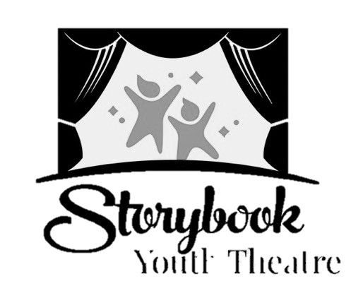
Audition Form

NAME: _______________________________________________________________
AGE: _______
SIZE: Shirt:_______ Pant/Skirt:_______ Dress(if applicable): ________ Shoe:_______

Contact Email for Cast List and Basecamp:______________________________________

TOP 3 CHARACTERS I WOULD LIKE TO PLAY (Please Label 1-3 on your choice):
___Mal ___Maleficent ___ Ben ____Jane ___Maurice
___Evie ___Grimhilde ___King Beast ____ Chad ___Coach
___Jay ___Jafar ___Queen Belle ____ Audrey ___Snow White
___Carlos ___Cruella de Vil ___ Fairy Godmother____ Doug
___Featured Ensemble (Royal Page, Royal Guard, Smitten Kids, Auradonians 1 &2, Coronation Guest 1 & 2, Auradonian Choir)

___Ensemble (Isle Ensemble, Auradonians, Coronation Crowd
Will you accept an Ensemble role? (Circle one) YES NO
If NO, please state why: ___________________________________________________
CONFLICTS (Please List any conflicts with the tentative schedule. Please note that TECH rehearsal and SHOW dates are MANDATORY.)

EXPERIENCE: (Please list your experience here if you have not brought a resume. If this is your first production or audition, please write that and WELCOME!)
- SHOW: ROLE:
- SHOW: ROLE:
- SHOW: ROLE:

DIRECTOR’S NOTES (please do not write below this line):

