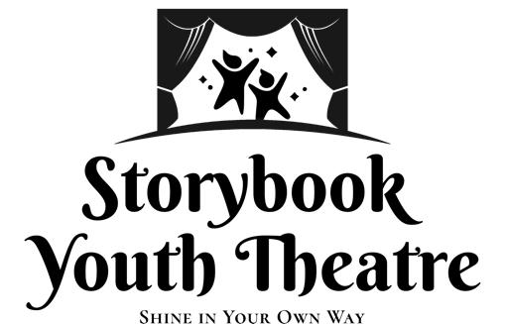
Macbeth
Audition Form
NAME: _______________________________________________________________
AGE: _______
SIZE: Shirt:_______ Pant/Skirt:_______ Dress(if applicable): ________ Shoe:_______
Contact Email for Cast List and Basecamp:______________________________________
Additional Basecamp Email (optional): _________________________________________
TOP 3 CHARACTERS I WOULD LIKE TO PLAY (Please Label 1-3 on your choice):
___Will/Banquo ___Ross ___ Servant
___Richard/Macbeth ___Macduff ___ King Duncan
___Witch 1 ___Angus ___Attendant(s)
___Witch 2 ___ Seyton ___Soldiers (s)
___Witch 3 ___Lady Macbeth ___Fleance
CONFLICTS (Please List any conflicts with the tentative schedule. Please note that TECH rehearsal and SHOW dates are MANDATORY. Please be as specific as you can.)

EXPERIENCE: (Please list your experience here if you have not brought a resume. If this is your first production or audition, please write that and WELCOME!)
- SHOW: ROLE:
- SHOW: ROLE:
- SHOW: ROLE:
DIRECTOR’S NOTES (please do not write below this line):

