Cinderella: Youth Edition
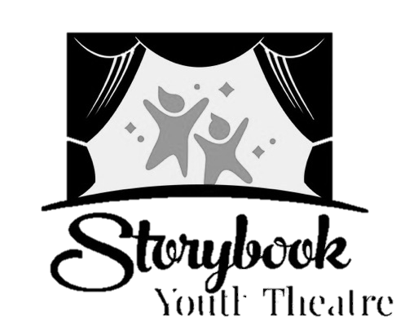
Audition Form

NAME: _______________________________________________________________
AGE: _______
SIZE: Shirt:_______ Pant/Skirt:_______ Dress(if applicable): ________ Shoe:_______

Contact Email for Cast List and Basecamp:______________________________________
Additional Basecamp Email (optional): _________________________________________
TOP 3 CHARACTERS I WOULD LIKE TO PLAY (Please Label 1-3 on your choice):
___Cinderella ___King ___ Godmother
___Stepmother ___Queen
___Joy ___Prince Christopher
___Portia ___Herald
___Featured Ensemble: Footman, Coachman, Mice/Horses, Miadens (11), Chef, Butcher, Cheese Steward, Dessert Chef, Family (Father, Mother, Daughter), Girl friends (3), Four Sisters, Grandmother, Little Boy, Fruit Vendor, Flower Girl

___Ensemble (Ball Guests, Townspeople, Soldiers)
Will you accept an Ensemble role? (Circle one) YES NO
If NO, please state why: ___________________________________________________
CONFLICTS (Please List any conflicts with the tentative schedule. Please note that TECH rehearsal and SHOW dates are MANDATORY.)

EXPERIENCE: (Please list your experience here if you have not brought a resume. If this is your first production or audition, please write that and WELCOME!)
- SHOW: ROLE:
- SHOW: ROLE:
- SHOW: ROLE:

DIRECTOR’S NOTES (please do not write below this line):

